I. PARAGRAPH HEAD INTO PRACTICE

1. Find the paragraph head. Underline the topic and circle the controlling idea.
Growing a garden can be fun, good exercise, and will provide fresh fruits and vegetables for the gardener. First, it is interesting to watch the seeds pop their heads above the soil for the first time. It is sometimes hard to believe that a little seed can become a large vine or plant in just a few weeks. What is more, planting the seeds and pulling weeds are good exercise for anyone. Gardening can cause you to burn 200-400 calories per hour. Finally, after watching the plant grow and produce, the gardener ends up with delicious tomatoes, beans, or other yummy produce from the garden. According to the National Gardening Association (NGA), 35 percent of households in the US grow food either at home or in a community garden. So, gardening entertains people, makes them healthy, and nourishes them.

2. Read the paragraphs. Choose the best head.

a.

____________________. Fruits are delicious. Examples of fruits are apples, oranges and bananas. Fruits have many vitamins and minerals, including Vitamin C, Vitamin E, and Potassium. For these reasons, it is a good idea to eat lots of fruit. | A. Everyone loves fruit.  B. Fruit is a delicious food to eat.  C. Fruit is a healthy and tasty food.

b.

____________________. First, many schools require two or more years of foreign language study for graduation. Secondly, learning other languages helps us communicate with people from other countries. Also, knowing a foreign language can lead to job opportunities. Finally, for many people, studying foreign languages is fun. So, there are many reasons to learn a foreign language. | A. In the USA, many students study the Spanish language.  B. It is important to learn foreign languages.  C. In college, people need to know foreign languages.

c.

____________________. Children who have a cell phone can call for help in an emergency. Also, they can always communicate with their parents. Finally, cell phones help children stay in contact with friends. For these reasons, when possible, children should have a cell phone. | A. There are many types of cell phones.  B. Cell phones help children call friends and parents.  C. Having a cell phone can help children in several ways.

d.
____________________. First, Canada has an excellent healthcare system. All Canadians have access to medical services at a reasonable price. Second, Canada has a high standard of education. Students are taught by well‐trained teachers and are encouraged to continue studying at university. Finally, Canada's cities are clean and efficiently managed. Canadian cities have many parks and lots of space for people to live. As a result, Canada is a desirable place to live. | A. Canada pays a lot of attention to healthcare and education.  B. Canada is one of the best countries in the world to live in.  C. Canada is one of the most beautiful countries in the world.

e.
____________________. One example of his legacy was the creation of a Hellenistic society. Hellenism was the combination of Greek, Persian, and Egyptian cultures. During this remarkable time period, people were encouraged to pursue a formal education and produce many different kinds of art. New forms of math, science, and design made a great impact on society. If this new way of life had not been as successful as it was, Alexander’s legacy would not be as memorable and ground-breaking. Because he conquered many countries and blended together many different cultures, Alexander the Great is widely recognized for his achievements and credited with being one of the greatest rulers in history. | A. The Hellenistic period covers the period of Mediterranean history between the death of Alexander the Great in 323 BC and the emergence of the Roman Empire.  B. After Alexander the Great's invasion of the Achaemenid Empire in 330 BC and its disintegration shortly after, the Hellenistic kingdoms were established throughout south-west Asia, north-east Africa and South Asia.  C. Alexander the Great was a successful ruler because his actions created long-lasting effects on cultures that continue to the present day.

3. Write a paragraph head grouping the following sentences together.
a.
Group of sentences | Paragraph head
- Crocodiles are grayish green.  - Crocodiles have triangular snout.  - Alligators like fresh water.  - Alligators have a rounded snout.  - The fourth tooth is exposed on a crocodile when their mouth is closed. | There’s a great difference between Aalligators and Ccrocodiles.
b.
Group of sentences | Paragraph head
- Many people gather to watch the bull-riding.  - Others come for the food.  - The rides at the country fair are awesome!  - Everyone can find something they enjoy doing. | The country fair is enjoyable for the whole family.
c.
Group of sentences | Paragraph head
- Butterflies lay their eggs on leaves.  - Then, the eggs hatch into small larvae.  - The larvae grow and turn into caterpillars.  - The caterpillars spin a chrysalis or cocoon. | The life cycle of butterflies is very simple.
d.
Group of sentences | Paragraph head
- Butterflies lay their eggs on leaves.  - Then, the eggs hatch into small larvae.  - The larvae grow and turn into caterpillars.  - The caterpillars spin a chrysalis or cocoon. | (same as C) The life cycle of butterflies is very simple.
e.
Group of sentences | Paragraph head
- Clarion angelfish live in reef waters.  - Its thin body helps it slip in and around rocky reefs.  - A large Clarion angelfish is eight inches long.  - They eat sponges, sea grasses, and algae. | Angelfish is a fascinating creature.
f.
Group of sentences | Paragraph head
- People need to exercise daily.  - Everybody needs to eat variety of fresh fruits and vegetables.  - Water is important.  - Calcium is found in a variety of foods other than milk. | Healthy routines are very important.

4. Write a paragraph head for three of the topics below.

- The technological singularity.
- Playing a musical instrument.
Playing a musical instrument is a great skill, since
it helps you mentally and physically.
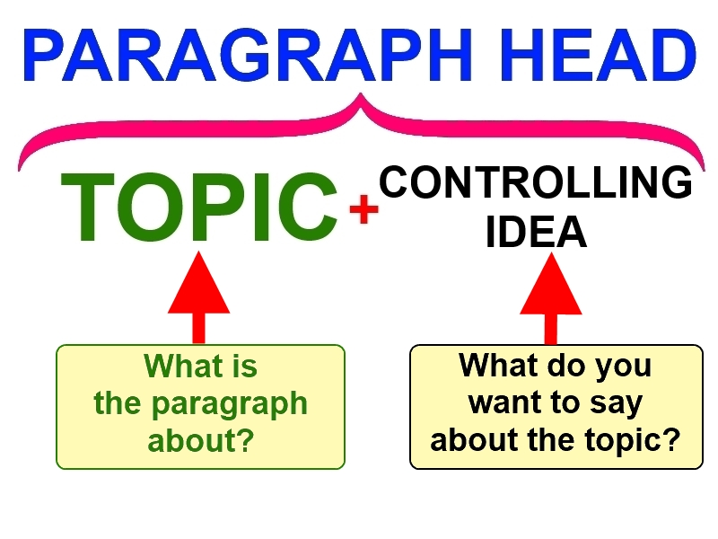
- Cybersecurity.
Cybersecurity is
one of the most
important fields
in computer science/.
- Start-ups.
- Cryptocurrency.
Cryptocurrency is
one of the safest ways
to handle money.

II. SUPPORTING SENTENCES INTO PRACTICE

1. Find the supporting sentences. Underline the explanation and circle the details. Find examples of statistics, an expert's opinion, or a fact.

Growing a garden can be fun, good exercise, and will provide fresh fruits and vegetables for the gardener. First, it is interesting to watch the seeds pop their heads above the soil for the first time. It is sometimes hard to believe that a little seed can become a large vine or plant in just a few weeks. What is more, planting the seeds and pulling weeds are good exercise for anyone. Gardening can cause you to burn 200-400 calories per hour. Finally, after watching the plant grow and produce, the gardener ends up with delicious tomatoes, beans, or other yummy produce from the garden. According to the National Gardening Association (NGA), 35 percent of households in the US grow food either at home or in a community garden. So, gardening entertains people, makes them healthy, and nourishes them.

2. Choose the answer that best supports the paragraph head provided.

a. Knowing how fires burn is the key to putting them out.
- Dry Christmas trees are the most frequent cause of home fires during the Christmas season. One should keep them watered.
- Grease fires are caused by grease getting too hot and splattering out of the pan. The pan then catches on fire.
- Most fires are caused by man’s carelessness. The best way to stop fires is to educate people to be more careful.
- Fires require heat sufficient to cause combustion, fuel, and oxygen. If you take any one of those away the fire will die.

b. Being computer literate has become important in today’s job market.
- Now that everyone has an opportunity to go to school and get a high school diploma, society has come up with a new way to distinguish the social ranks.
- Only the wealthy can afford to have computers, so they are the only ones who can learn how to use them. So, the rich stay rich, and the poor get poorer.
- People without computer proficiency will end up with lower paying employment because computers have become the backbone of today’s economy.
- Computers are so complicated that they are hard to learn how to use. So, you really have to be brilliant to use them.

c. Adopting a dog should be as carefully considered a decision as having a child.
- Both need loving companionship, food, shelter, medical care, exercise and stability. Both are totally dependent on you.
- Cats are easy to take care of and don’t demand a lot of attention. On the other hand, dogs are more friendly and loyal.
- Dogs are great companions for children and teach children a sense of responsibility. A dog will also protect your child from strangers.
- Some dogs are better behaved and easier to get along with than some children are.

d. Dandelions are an underrated flower.
  - Dandelions grow almost everywhere. Dedicated gardeners spend much time and energy to remove them.
  - Dandelions don’t have as lovely a fragrance as a rose. They are not so fragile as violet is either.
  - They do not require a lot of dedicated care to bloom, and children can make them into happy bouquets for moms.
  - Dandelions were so named because the petals are shaped like the teeth of a lion.

e. Sunset is a time of contrasts.
- People hurry home along busy streets. Rush-hour traffic brings out the worst in tired drivers.
- The distant sky is awash with brilliant color, while middle distance buildings and trees seem charcoaled in.
- Mosquitoes come out at sunset and drive loiterers indoors.
- You will hear the sounds of families at dinner, children being called in from play, and dogs barking to be let in.

3. Choose the sentence that does not belong because it is not connected closely with the controlling idea.
a.
(1) Independent audits are a good way to help businesses stay on solid financial footing.  (2) Independent audits are done by people who are outside of the company being audited.  (3) Such an audit helps prevent a company from overextending its resources.  (4) It also serves to uncover misappropriation of funds and keep transactions honest. | A. Sentence 1  B. Sentence 2  C. Sentence 3  D. Sentence 4

b.
(1) A veterinary technician needs to know how to give different animal types physical examinations, prepare animals for and assist in surgery, clean teeth, administer medical treatments, and keep records.  (2) A veterinary technician also needs to know how to perform blood counts on a variety of domestic animals.  (3) A vet tech needs to have a lot of compassion for animals.  (4) Many skills are required to be a veterinary technician. | A. Sentence 1  B. Sentence 2  C. Sentence 3  D. Sentence 4

c.
(1) Employers have financial responsibilities that extend beyond their employees’ pay checks.  (2) They are required to provide environments that are safe from sexual harassment.  (3) They are required to pay taxes to both the state and federal governments in addition to what they withhold for the employee.  (4) They are also required to have the W2 forms to the employee for the preceding year by January 31. | A. Sentence 1  B. Sentence 2  C. Sentence 3  D. Sentence 4

d.
(1) Journaling is a worthy exercise.  (2) It helps hold memories of happy events.  (3) It provides a safe place to explore feelings and ideas.  (4) Many famous people keep journals. | A. Sentence 1  B. Sentence 2  C. Sentence 3  D. Sentence 4

e.
(1) Everyone likes to find a bargain.  (2) Yard sale shoppers save money buying previously owned items.  (3) Sellers make money and prevent waste.  (4) Yard sales are a win-win event. | A. Sentence 1  B. Sentence 2  C. Sentence 3  D. Sentence 4

4. Write supporting sentences for ONE of the paragraph heads below.
Explain the controlling idea in three ways.
Give different details for each explanation
(a fact, an anecdote, an expert's opinion, or statistics).

- Dogs make excellent pets.
-Studies have shown that petting dogs for 10 minutes reduces stress significantly.
-Statistically, dog owners take 2760 more steps per day on average compared to non-owners.
-Dogs makes a person more social, whether while just walking your dog or just having him it in general, it sparks up conversations naturally.
- My friend and I have very different personalities.
- Cyber security awareness training is often useless.
- A really good place to study is the university library.
- Learning a second language creates job opportunities.
- One of the most valuable tools for students is the computer.
- Cryptocurrency’s future outlook is still very much in question
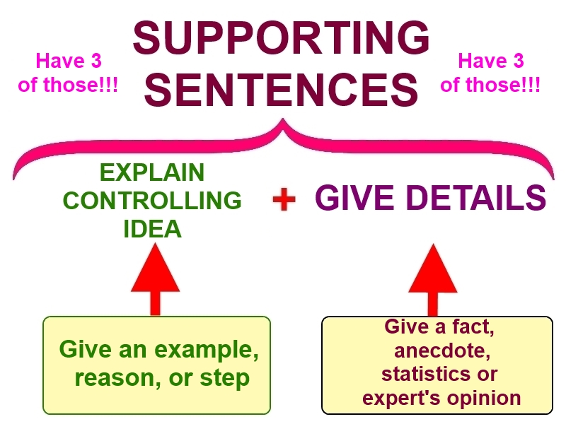
III. CONCLUDING SENTENCE INTO PRACTICE

1. Underline the concluding sentence.
Growing a garden can be fun, good exercise, and will provide fresh fruits and vegetables for the gardener. First, it is interesting to watch the seeds pop their heads above the soil for the first time. It is sometimes hard to believe that a little seed can become a large vine or plant in just a few weeks. What is more, planting the seeds and pulling weeds are good exercise for anyone. Gardening can cause you to burn 200-400 calories per hour. Finally, after watching the plant grow and produce, the gardener ends up with delicious tomatoes, beans, or other yummy produce from the garden. According to the National Gardening Association (NGA), 35 percent of households in the US grow food either at home or in a community garden. So, gardening entertains people, makes them healthy, and nourishes them.

2. Write a conclusion sentence that fits each paragraph.
a.
Children should all own cell phones. When children have a cell phone, parents can always contact them. This helps keep children safe, and it reduces stress for parents. Also, children who have cell phones can learn to use helpful apps. For example, if a child is lost, he or she can use a map on a cell phone to find the way home. Finally, a child who has a cell phone can communicate with friends. This helps children be social.
Therefore, it is important for children to have cell phones

b.
Everyone should take a multi-vitamin each day. People need many vitamins and minerals to stay healthy. It is impossible to get all vitamins and minerals from food. In this case, a multi-vitamin is an inexpensive and easy way to get the vitamins that food does not provide. Some people feel that extra vitamins are unnecessary for good health. This might be true, but while some health issues can be caused by insufficient vitamins and minerals, few to none are caused by taking a multi-vitamin.
Therefore, it is important to add multi-vitamins to your daily routine diet

c.
People should walk more and drive less. These days, people drive when it is possible to walk. If a store, for example, is three blocks away, why not get outside, exercise, and walk to the store? This is healthier than driving. It is also cheaper because the cost of gas is reduced when less gas is used. Plus, studies have shown that being outside and getting exercise increase a person’s sense of happiness and reduces stress levels.
Therefore, it is important for people to walk rather than drive.

d.
Learning a foreign language is beneficial in many ways. First, knowing more than one language creates gives an individual a gateway into other cultures. Secondly, learning another language can increase job opportunities both at home and in other locations. Finally, studies have shown that people who are bilingual seem to have an advantage on various tests, including readingtests and standardized tests.
For this reason these reasons, it is good to learn another language

e.
Washington DC is an interesting place for tourists to visit. One reason Washington DC is an excellent destination is the many free museums visitors can see. Another reason this is a nice city is the large metro system. The Washington DC metro goes to three states, including Washington DC, Maryland, and Virginia. There are many tourist attractions that are accessible by metro. Finally, Washington DC has many forms of entertainment including concert halls, various well-known and moderately priced restaurants, parks, and other sites that visitors enjoy.
That’s why Therefore, Washington DC is worth visiting.

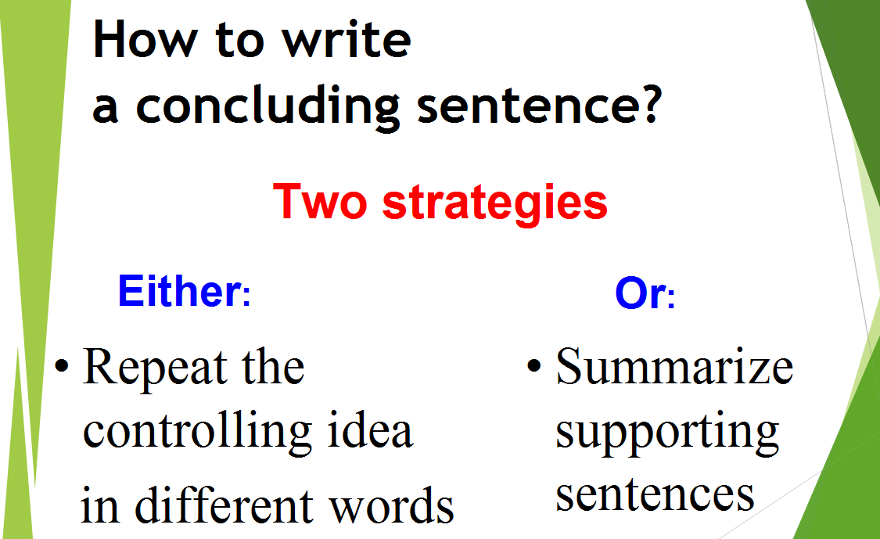
IV. TRANSITIONS INTO PRACTICE

1. Find the transitions. Underline them.
Growing a garden can be fun, good exercise, and will provide fresh fruits and vegetables for the gardener. First, it is interesting to watch the seeds pop their heads above the soil for the first time. It is sometimes hard to believe that a little seed can become a large vine or plant in just a few weeks. What is more, planting the seeds and pulling weeds are good exercise for anyone. Gardening can cause you to burn 200-400 calories per hour. Finally, after watching the plant grow and produce, the gardener ends up with delicious tomatoes, beans, or other yummy produce from the garden. According to the National Gardening Association (NGA), 35 percent of households in the US grow food either at home or in a community garden. So, gardening entertains people, makes them healthy, and nourishes them.

2. Fill the gaps with the most appropriate transitions.

SOURCES FOR COLLEGE WRITING

Students can draw on a variety of sources to help them with writing assignments. (1)___Firstly____ (idea explanation 1), they can draw on personal experiences. (2)___For example____ (detail 1), for an assignment about communication skills, a writer might think about the way he or she communicates through conversations with others while at work or at home. (3)___Similarly____ (detail 2), a writer might look at ways he or she communicates with others electronically via email or texting or Facebook. Students might (4)___Also ___ (detail 3) find examples of written communication skills by looking at skills they’ve learned for previous writing assignments. (5)___Secondly___ (idea explanation 2), student writers can look for ideas from other people’s experiences. (6)___For instance __ (detail 1), writers can interview other students or even family members. (7)__On the other hand ___ (detail 2), a writer may have heard others talk about this topic, maybe in class. (8) ___Another____ (detail 3) source would be television shows on the topic of communication. (9)___Ultimately _____ (idea explanation 3), college writers may find that they need to do some research to complete an assignment. (10)___In fact ___ (detail 1), lots of experts have written articles or books on the topic of communication skills. (11)__Therefore __ (detail 2), a search of “communication skills” on the internet might provide useful information; (12)__accordingly __ (detail 3), reference librarians can help students find research materials in special collections or databases. (13)__In conclusion __, college writers need to be able to draw on a combination of personal experience, observations of others, and research materials to develop their written assignments.

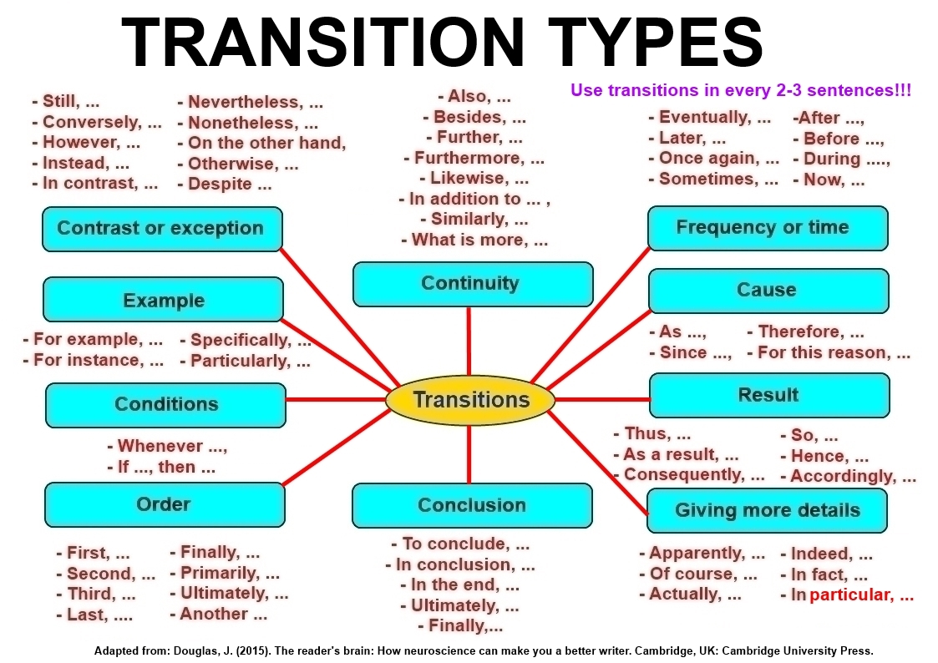
V. PARAGRAPH INTO PRACTICE

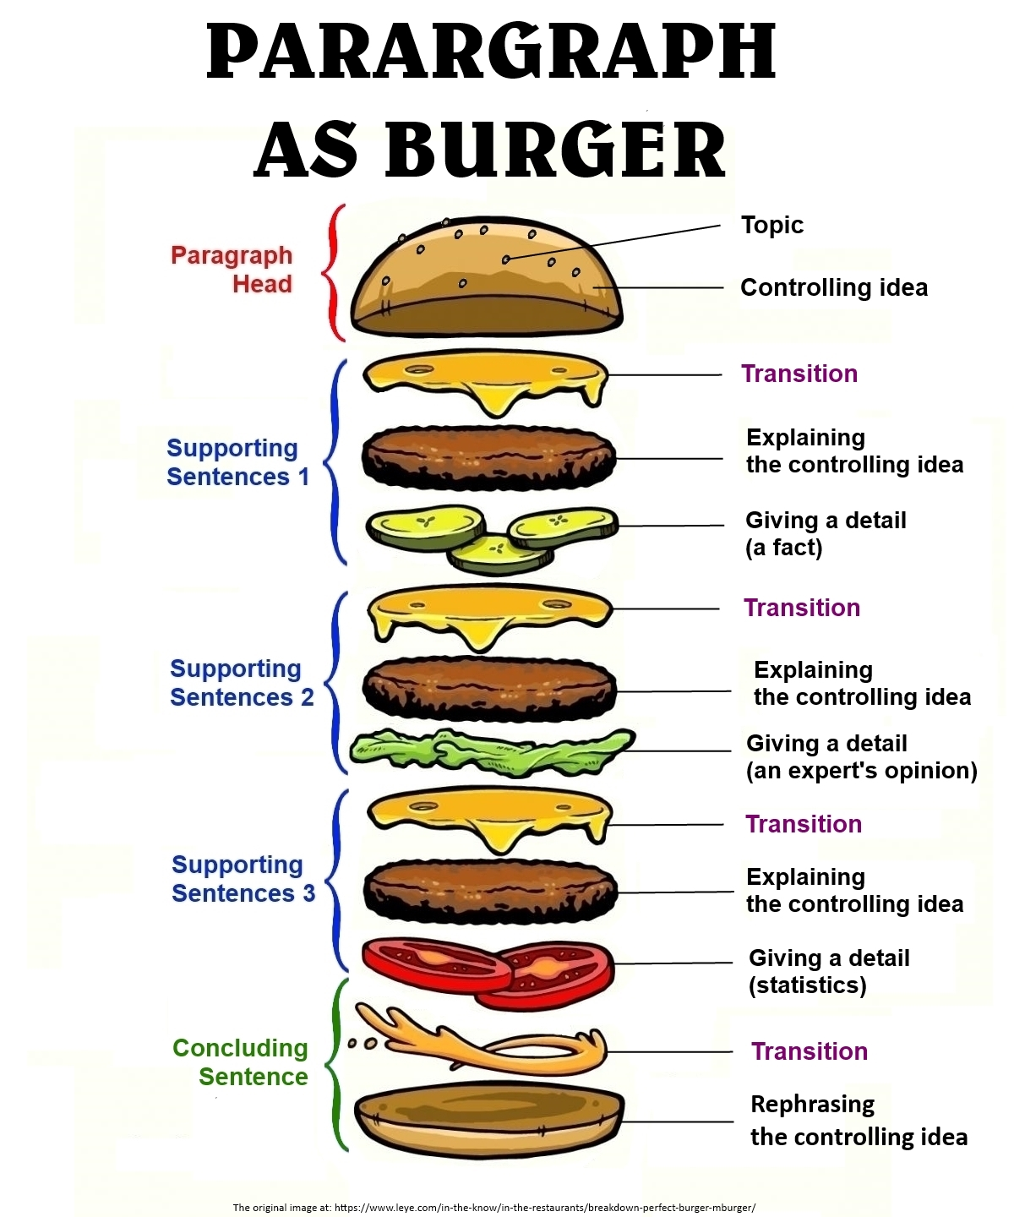
1. Choose one of the topics below and write a paragraph.

- Robots.
- Artificial intelligence.
- Cybersecurity.
- Music.
- Topic of your choice.
(Toxicity in online games)

Online games can be a very harsh and toxic place, and it ruins they can ruin any player’s experience. First, the competitive atmosphere in an online game can spark up a lot of arguing between rivals or even teammates, . A study that was conducted in 2019 showed that 74 percent of the respondents say said that they’ve had experienced some form of harassment while playing online games. Another reason for toxicity can be for the player’s ethnicity, race, religion, gender, and sexual orientation, for - . For example, women statistically get harassed three times as much as men while playing online games. Specifically, toxicity is most likely originating from originated in the lack of monitoring, based . Based on an expert’s opinion, the reason for toxicity in online games is deindividuation, where a person’s identity fades in the group, which leads to less social accountability. In conclusion, online games are not a safe space where you just have fun, and most of the times it leads to a horrible experience.

Mosab, you have produced several FUSED sentences as you combined supporting ideas and details into one sentence. Next time write them as separate sentences.

2. Work in pairs. Run your partner's paragraph against the Checklist (see the next page). Provide feedback to your partner.

CHECKLIST
Is the paragraph effective?
I’m assuming that the grader is the one that supposed to fill this out, but just in case I’m the one supposed to do it based on my opinion everything is YES except the one about summarizing supporting sentences because I preferred just repeating the controlling idea in different word.
Things to check | Yes | No
1. Paragraph head
Does the paragraph have a head?
Is the paragraph head no more than 2 sentences long?
Is the paragraph head 1/3 of the whole paragraph (excluding the concluding sentence)?
Does the head have a topic?
Does the head have a controlling idea?
Does the writer announce the topic?
Is the paragraph head in complete sentences (subject + verb)?
2. Supporting sentences
Does the paragraph have supporting sentences?
Are the supporting sentences 2/3 of the whole paragraph (excluding the concluding sentence)?
Is the controlling idea explained at least 3 times?
Is the controlling idea explained using reasons, examples or steps?
Do the Supporting Sentences 1 explain the controlling idea?
Do the Supporting Sentences 2 explain the controlling idea?
Do the Supporting Sentences 3 explain the controlling idea?
Are there details for every explanation?
Do the details use facts, anecdotes, expert's opinions or statistics?
3. Concluding sentence
Does the paragraph have a concluding sentence?
Does the concluding sentence repeat the controlling idea in different words?
Does the concluding sentence summarize supporting sentences?
4. Transitions
Is there a transition from the paragraph head to Supporting Sentences 1
Is there a transition between Supporting Sentences 1 and Supporting Sentences 2?
Is there a transition between Supporting Sentences 2 and Supporting Sentences 3?
Is there a transition from Supporting Sentences 3 to the Concluding Sentence?
5. Overall
Is the paragraph logical?
Is the paragraph well-structured?
Is the paragraph clear?
Is the paragraph concise?

Adapted from:

- http://www.englishunits.com/wp-content/uploads/Topic-Sentence-of-a-Paragraph.pdf
- https://www.csun.edu/sites/default/files/Auerbach-Handout-Paragraph-Writing-Examples.pdf
- https://en.wikipedia.org/wiki/Hellenistic_period
- http://www.teach-nology.com/worksheets/language_arts/paragraphre/parare6.pdf
- https://www.k12reader.com/topic-sentences/identify_the_topic_sentence.pdf
- https://floydmiddle.typepad.com/files/topic-sentence-examples.pdf
- http://thenationshealth.aphapublications.org/content/47/5/17
- http://www.farmerfoodshare.org/farmer-foodshare/2017/6/15/gardening-boom-1-in-3-american-households-grow-food
- http://www.fldoe.org/core/fileparse.php/3/urlt/supsen2.doc
- https://www.cpomagazine.com/cyber-security/common-problems-and-limitations-of-cyber-security-awareness-training/
- https://online.stanford.edu/future-for-cryptocurrency
- https://www.englishunits.com/wp-content/uploads/Conclusion-Sentence-Quiz-2.pdf
- https://www.elcamino.edu/academics/basicskills/DLA_EngB_Transitions_ECC.pdf

